Pagemark User Manual
Version 0.13.2
Revision 1.0

Pagemark — User Manual
Version 0.13.2 · A private, fully local book tracker for Android
*Screenshots show sample books and were captured from the Android app (0.13.2).*

Quick start
- Open Pagemark. Three short welcome screens appear (Skip any time). At the end choose Try it with 5 sample books to look around, or add your first real book.
- Add a book. Tap Add book, type a title (or tap the barcode icon and scan the back cover), then tap the right result. Its page opens.
- Say what you are doing with it. On the book page tap Log a read, choose *Want to read*, *Reading* or *Finished*, and tap stars if you like.
- Keep it safe. Open Settings → Backup and restore and choose Save a copy as a file (set a password). Pagemark will remind you to do it again.
- Need help? Settings → How to use Pagemark has short steps for everything, with a search box. It works without internet.

1. What Pagemark is
Pagemark is a reading log that lives only on your phone. You record what you read or listen to — print, e-book or audiobook, any genre — with your rating, dates, progress and private thoughts. Book details and cover art come from the free Open Library; everything you write stays on your device unless you choose to export or back it up.
There is no account, no server and no tracking. Pagemark has no ads, no analytics and no AI inside the app (see Our promise to you in §8d). The only times it uses the internet are: looking up a book (on Open Library and, unless you turn it off, Google Books), checking for an app update on the GitHub version, and the cloud app you may choose for a backup folder.

2. The four tabs
Tab | What it is
Library | Your books. Search, filter, sort, shelves, series — in five looks.
Locked | A private library behind a PIN and/or your fingerprint.
Stats | Your reading goal and charts.
Settings | Themes, updates, export, backup, privacy, trash, diagnostics.

A small dot on Settings means an app update is waiting.
Tablets and phones turned sideways. On a screen about 600 dp wide or more (a tablet, a folded foldable, a phone in landscape) the tabs move to a bar on the left. On a larger screen (about 840 dp, a tablet) your Library and the book you tap sit side by side; the book fills the right-hand pane and Choose a book to see it here shows until you pick one. Lists and forms stay a comfortable reading width instead of stretching across the screen. In landscape on a short screen the *Currently reading* strip is left out so the list has room.
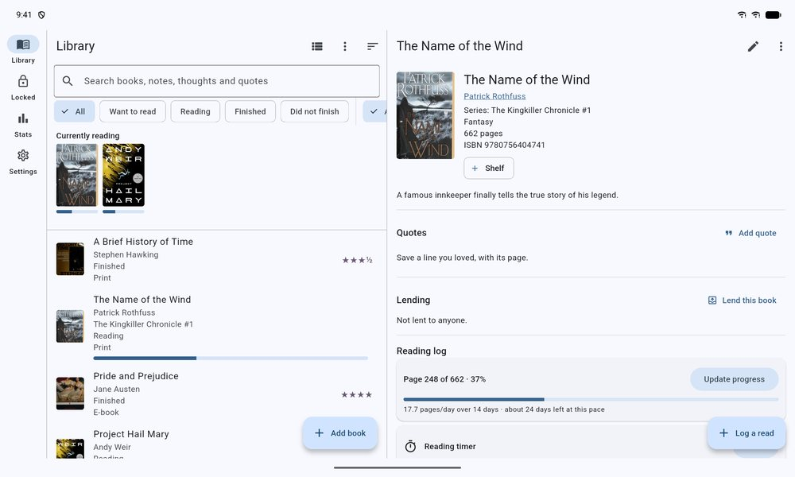
A tablet: the Library and the open book side by side
Back. On Stats, Locked or Settings the Back gesture takes you to the Library first; Back on the Library leaves the app.
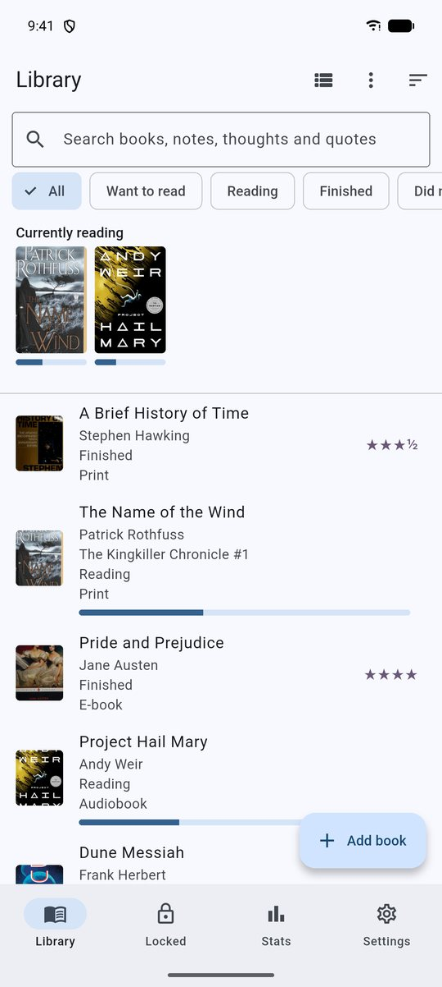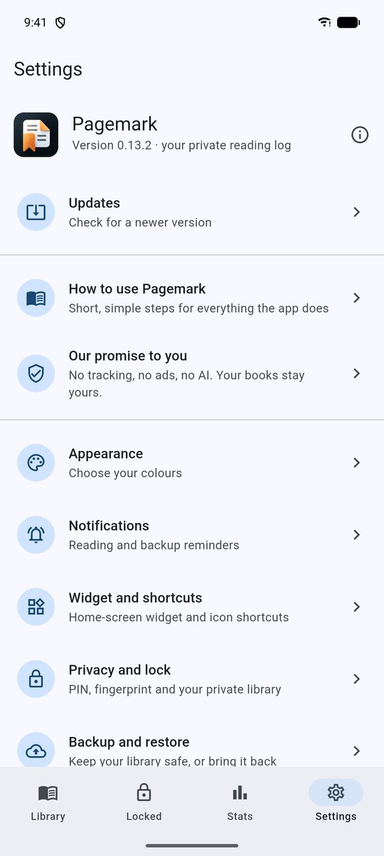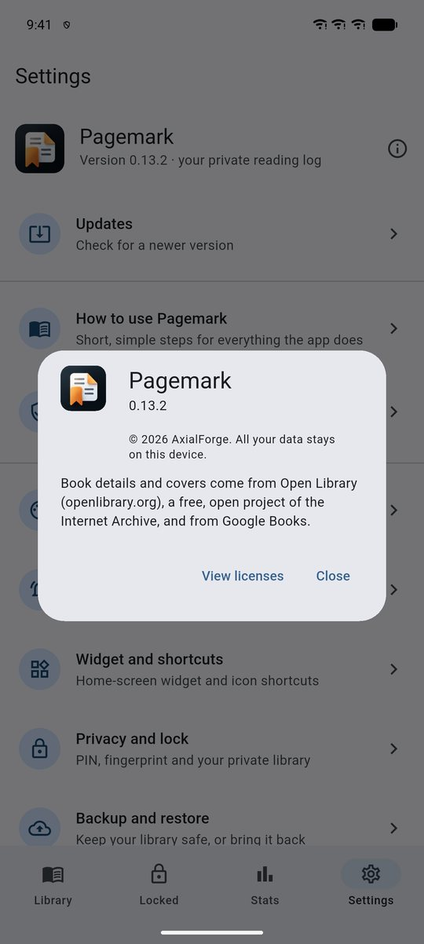
Library · Settings · About

3. Adding a book
Tap Add book (bottom of the Library).
- Search — type a title or author and press search. Tap a result to add it.
- By ISBN — type or paste an ISBN into the same box and it is looked up directly. Invalid ISBNs are explained instead of searched.
- Scan — tap the barcode icon at the top and point the camera at the ISBN barcode on the back cover. Only real book barcodes are accepted; the torch button helps in dim light.
- Manually — if a book isn't found, choose Add by hand and enter a title; fill in the rest later with Edit.
If the book is already in the same library (same ISBN, or the same title and author) Pagemark warns you and offers to open the existing one. The main and locked libraries never compare against each other, so the main library can't reveal a locked title.
Results are ranked so real editions come first. Summaries, study guides and workbooks that Open Library also lists are tucked behind Show N more results (if every result is that kind of book, they are all shown).
Descriptions are fetched a moment after the book is saved when Open Library has one.

Two sources, merged
Searches ask Open Library and Google Books together and merge the answers: more books are found, and gaps (a missing cover, page count, publisher or description) are filled from the other source without ever overwriting what one already knows. If one source is down the other still works. To use Open Library only, turn off Settings → Your library → Also search Google Books.

Scanning a whole shelf
On Add a book tap the icon with a tick (Scan many books). The camera stays open: point it at one barcode after another. Each new book gives one click and a buzz and is looked up and added on its own. Books you already have are skipped, a barcode seen twice is ignored, and any book that could not be found (or could not be looked up because the search was busy or you were offline) is listed with the reason so you can add it by hand or scan it again. In the Locked library the one-time internet warning shows first.
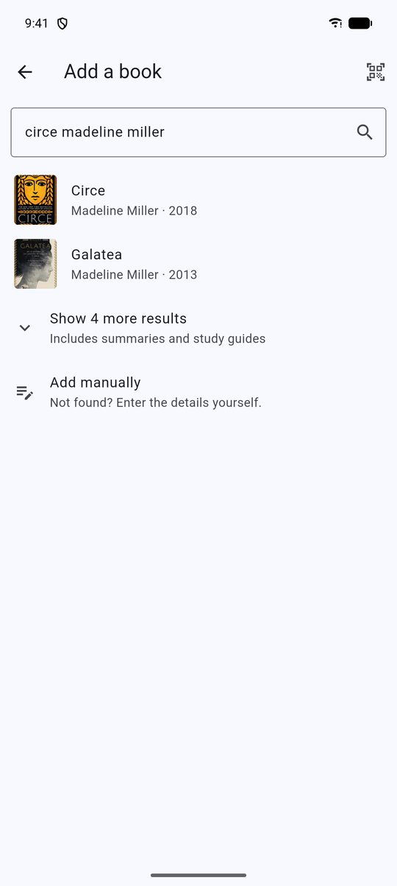
Add a book: search results

4. The book page
Tap a book to open it. You'll see the cover, details, tags and shelves, your notes, and the Reading log.
- Edit (pencil) — title, author, series and series number, genre, tags, publisher, ISBN, cover URL, year, pages, description and private notes.
- ⋮ menu — Refresh details from the internet, move the book to or from the Locked library, save, choose or remove its cover picture, or Move to Trash.
- Log a read — records a new read-through (see §5). A book can have many reads: a re-read, or a print copy and an audiobook of the same title.

Shelves
Tap + Shelf on a book to put it on any number of shelves ("Comfort reads", "Book club", "Lent out"). Create new shelves from there. Remove a book from a shelf by tapping the × on its chip.
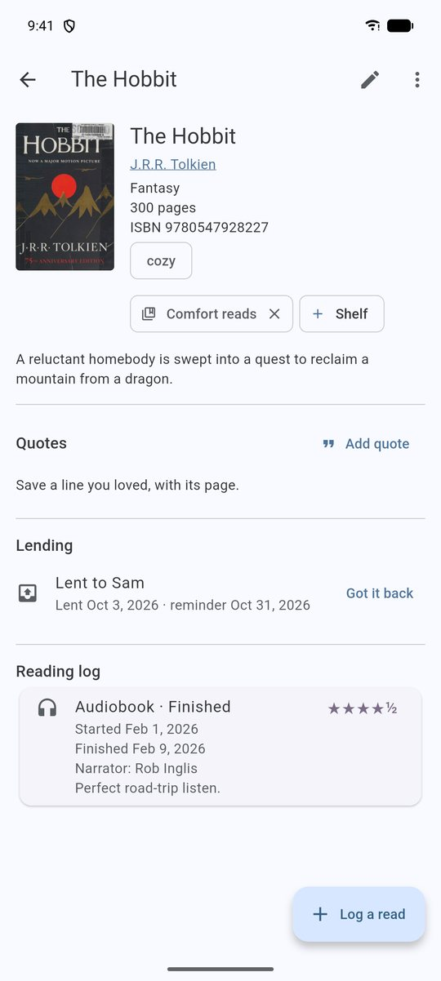
A finished book, with shelf and log

Refreshing a book's details
Open the book's ⋮ menu and choose Refresh details from the internet. Pagemark looks the book up again (by ISBN when it has one, else by title and author) and lists what it found. Details the book is missing are ticked for you; details you already have that differ are listed unticked, so your own edits are only changed if you tick them. An ISBN you have, and a cover you saved on the phone, are never replaced. Tap Update to apply the ticked ones. Choose another edition lists the editions Open Library knows (publisher, year, pages, ISBN, cover) and takes only those details from the one you pick.
In Edit, pages must be a whole number from 1 to 20,000 and the year between 1000 and 2100 (or left empty); anything else is refused with a message.
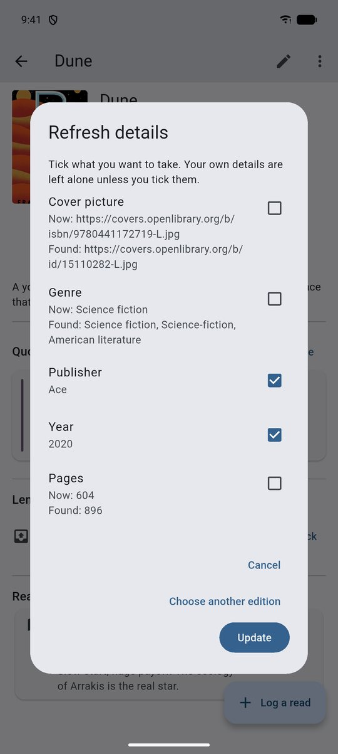
Refresh details: tick what you want to take

Lending a book
The Lending section on the book page records who has it. Tap Lend this book, type the name, and choose a reminder: *Tomorrow*, *In a week*, *In 2 weeks*, *In a month*, *In 2 months* or *No reminder*. The reminder is a notification at 10:00 that names neither the book nor the person (it can be read on a lock screen). Tap Got it back when it returns; that cancels the reminder. Returned loans stay in the list until you remove them with the bin.
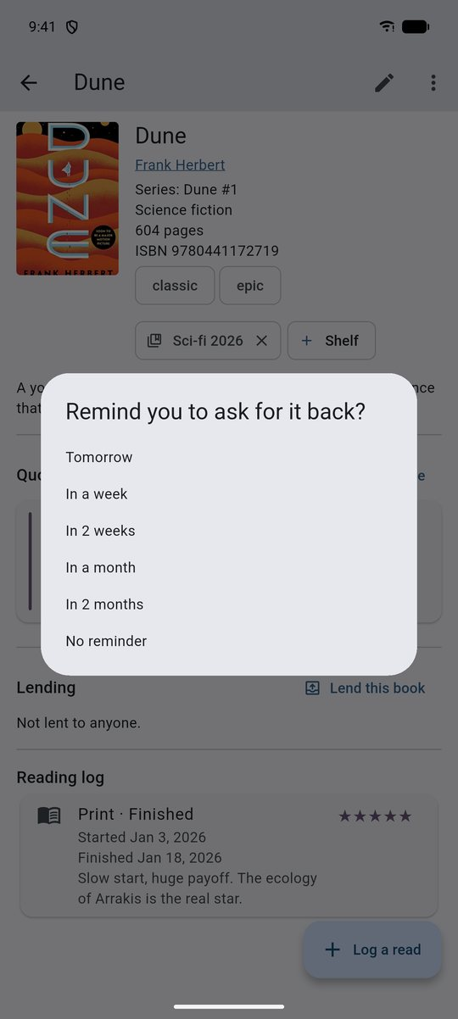
A book lent to Sam · Choosing a reminder

Series
In Edit, type the series name and the number in the series (decimals work: 2.5). Rows show the badge, and the Series screen (Library ⋮ menu) groups your books, shows how many you've read, and names what's next. It knows only the books you've added, not how long the series really is.
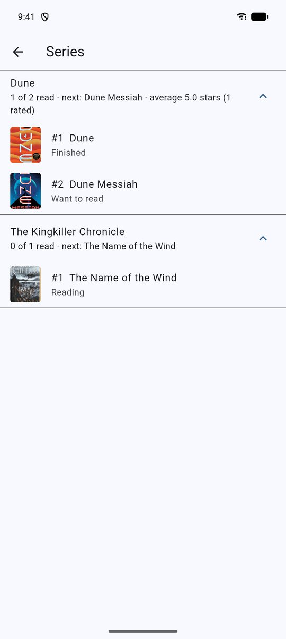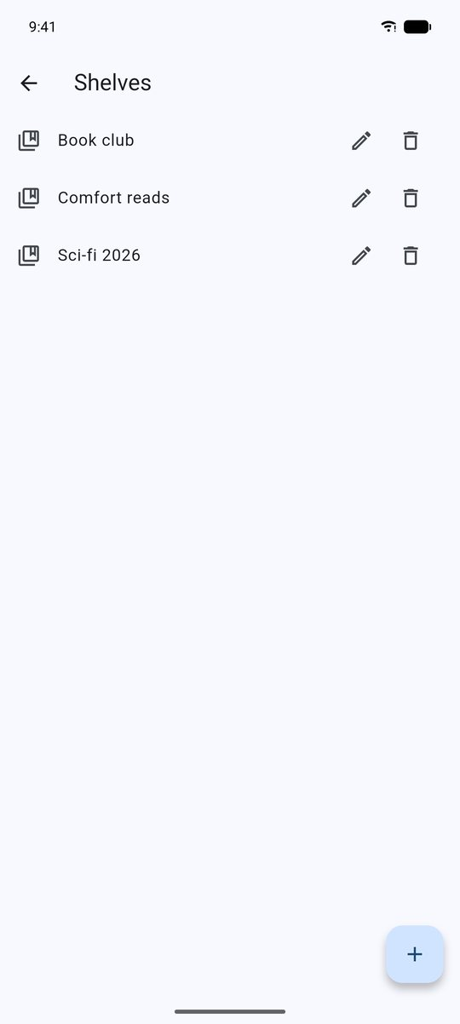
Series screen · Manage shelves

5. Logging a read
Choose Log a read (or tap an existing read to edit it).
- Format — Print, E-book or Audiobook. Audiobooks add a Narrator field.
- Status — Want to read, Reading, Finished, or Did not finish.
- Choosing *Finished* fills in today's date (change it if needed); choosing *Reading* or *Want* clears the finished date.
- A finished date earlier than the start date is refused.
- Started / Finished — tap to pick a date; Started today / yesterday are quick chips.
- Current page — shown while *Reading*.
- Rating — tap stars. Tap the left half of a star for a half star, the right half for a whole one; tap the same value again to clear.
- Time — minutes read or listened.
- Your thoughts — free text, private.
Delete a read with the bin icon (you'll be asked to confirm).

Reading progress
While a book has an active read, its page shows a progress card. Tap Update progress and enter the page you're on. If the book has a page count you get a progress bar, pages per day, and an estimate of days left at your pace. Reaching the last page offers to mark the read finished. Progress bars also appear on the Library list and in the Currently reading strip.

Reading timer
Under the progress card on a book you are reading, tap Start and read. Tap Stop when you put the book down: Pagemark shows how long you read and asks which page you are on (you can leave it empty). The minutes are added to the read's time and the day lights up in the Days you read calendar in Stats. The timer keeps counting if you close the app or lock the phone. Anything under half a minute is ignored. Only one timer runs at a time; if a timer is left running for a book you have since finished or deleted, every other book shows Stop it, where you choose to Save the time to that book or Throw it away.
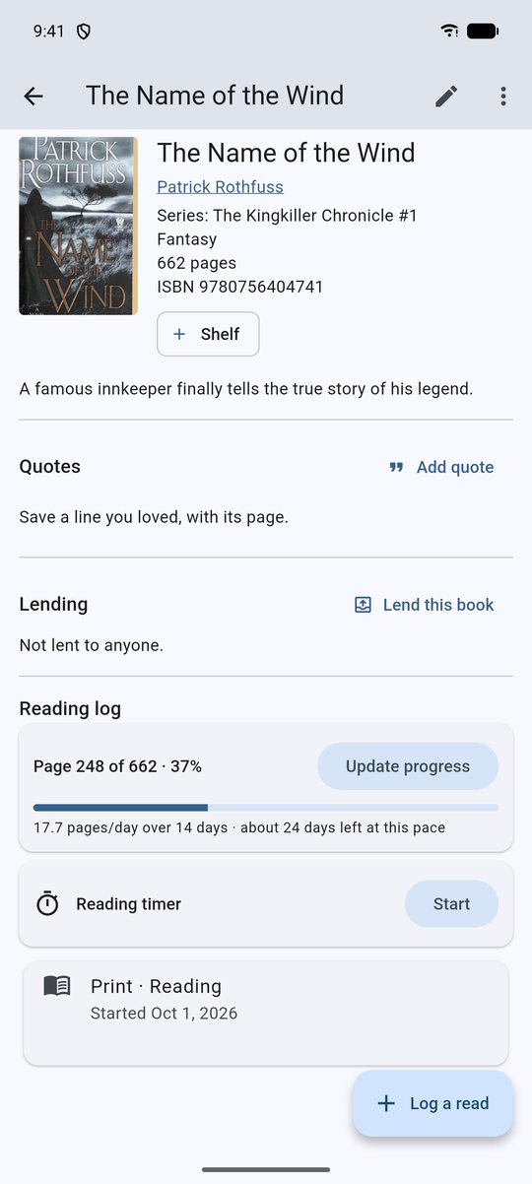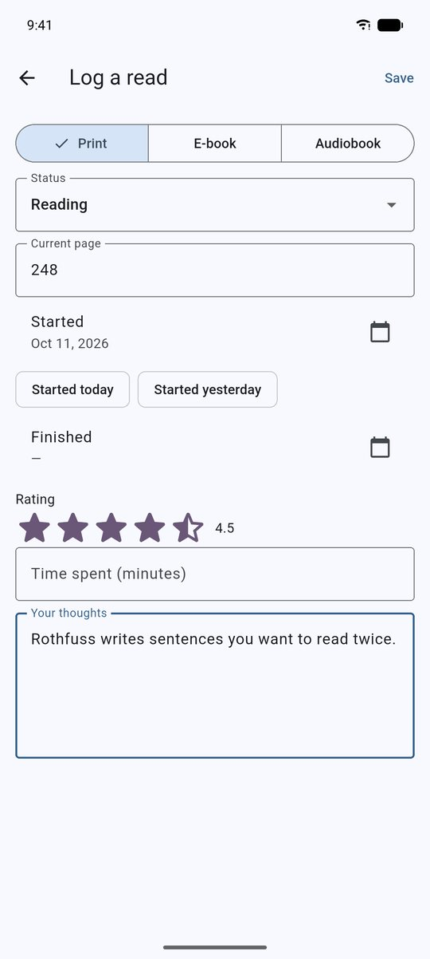
Progress card · Logging a read

Rating in more detail
Settings → Your library → Rate books in more detail adds optional stars to every read for Story, Characters, Writing, Pace and How it made me feel, plus Narrator on audiobook reads. They show on the book's page, in the Stats tab (your average for each) and in your saved lists. Quotes can also have stars ("How much you love it"), and the Series page shows the average rating of a series' books.

6. The Library
- Search — title, author, tags, genre and series.
- Filters — status chips (All / Want / Reading / Finished / DNF), format chips, and one chip per shelf. Tap a shelf chip again to clear it.
- Sort (⇅ icon) — Recently added, Title, Author, Rating.
- Currently reading — a strip of covers at the top when nothing is filtered.
- Remembered — your sort and filters are remembered separately for the main and locked libraries.
- Ratings show as stars (4.5 = ★★★★½) and average only your finished reads.
- ⋮ menu — Series, Read next order, Manage shelves (rename or delete shelves; deleting a shelf never deletes books) and How to use Pagemark.

Read next order
⋮ → Read next order lists the books you want to read. Press and hold one, then drag it where you want it; the order is remembered. (With TalkBack each book also offers *Move up* and *Move down*.) Above the list You might like next suggests up to three books from your own list: the next book in a series you have started, more from an author whose book you rated 4 stars or more, or a genre you rate highly. Tap Read first to put one at the top. The suggestions are worked out on your phone from your own books only, and the Locked library is never used.
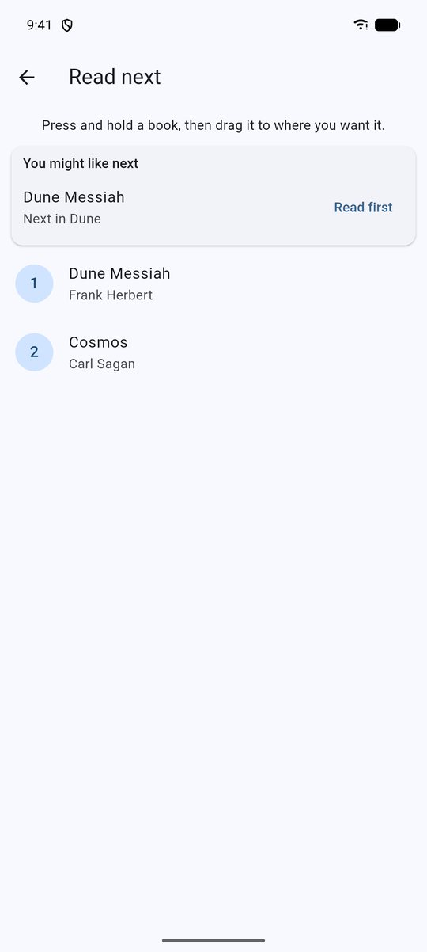
Read next, with suggestions
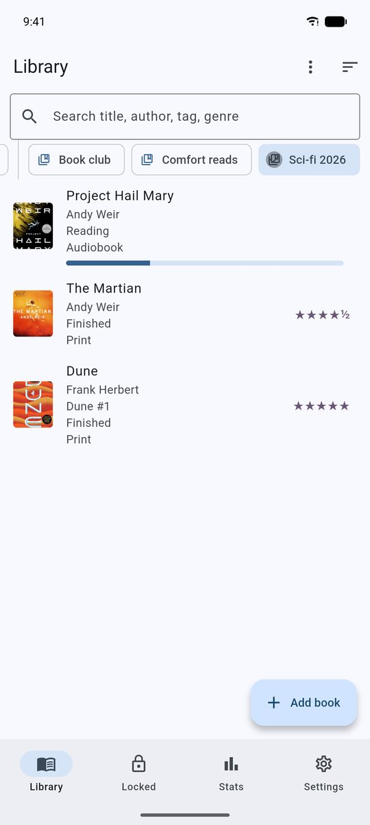
Filtering by a shelf

Library styles
Tap the style icon at the top of the Library to choose how your books are drawn. The choice is remembered separately for the main and locked libraries, and the Library cross-fades between styles.
Style | What it shows
Classic | A row per book: cover, title, series, status, format, rating and a progress bar
Cover wall | A grid of covers with rating stars and a progress strip; titles underneath
Bookshelf | Covers standing on wooden shelves, filled edge to edge; can be grouped under named shelves
Spines | Cloth-bound spines in natural binding colours with gold-leaf lettering and gilt bands; width follows the page count. A ribbon pokes out of the book you're reading and a small gold seal marks the ones you've finished. The author's surname joins the title when there is room
Compact | One tight line per book — the most books per screen

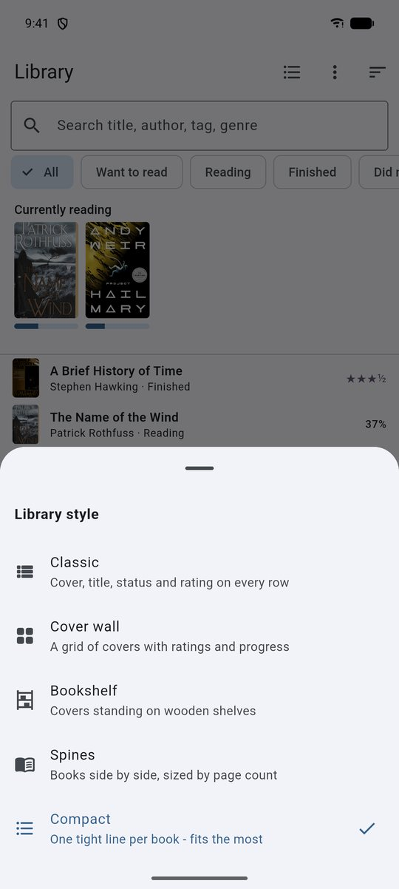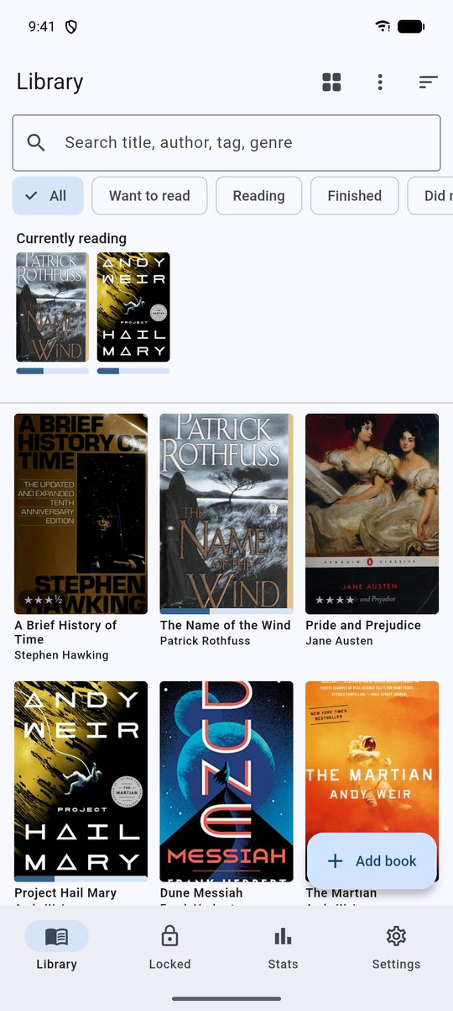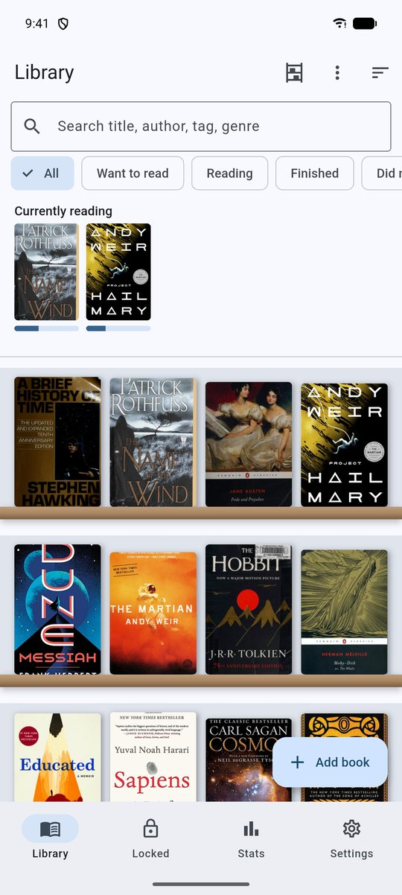
Choosing a style · Cover wall · Bookshelf
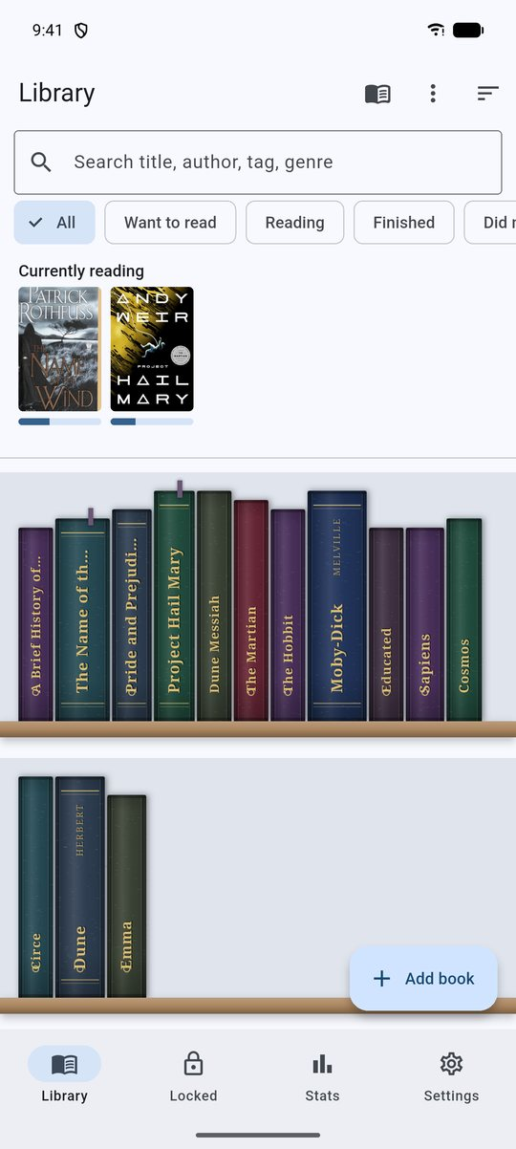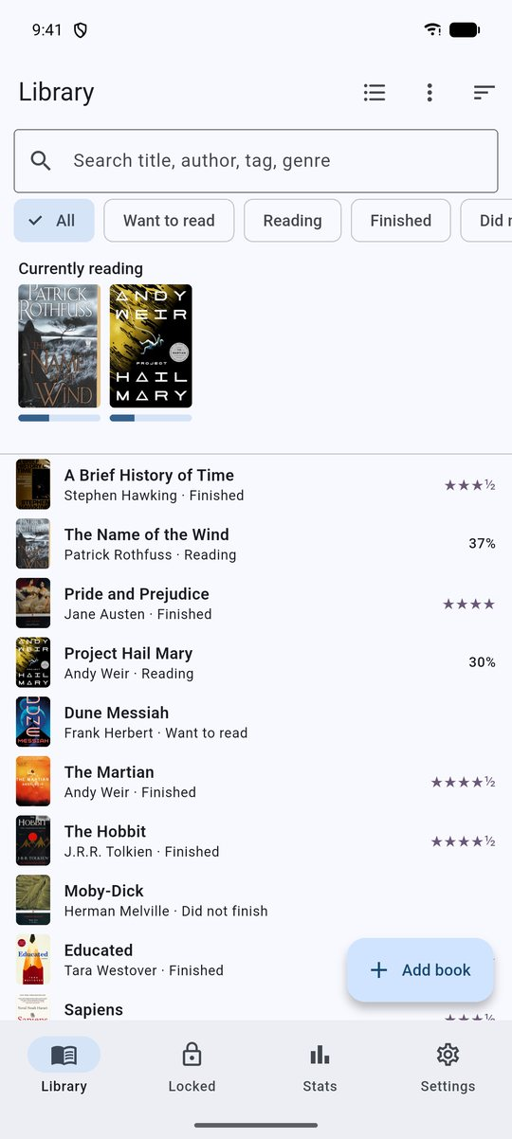
Spines · Compact
Filters, search, sort and shelves work the same in every style, and tapping any book opens its page.

Naming your shelves on the bookcase
In Bookshelf or Spines, open the style picker and switch on Group by my shelves. Each of your named shelves ("Comfort reads", "Book club" …) becomes its own wooden shelf under a brass nameplate showing its name and how many books it holds; books that aren't on any shelf collect under Not on a shelf. Tap a nameplate to rename that shelf — the new name appears everywhere (filters, the book page, Manage shelves). A book on two shelves stands on both. Create shelves from a book's page (+ Shelf) or ⋮ → Manage shelves.
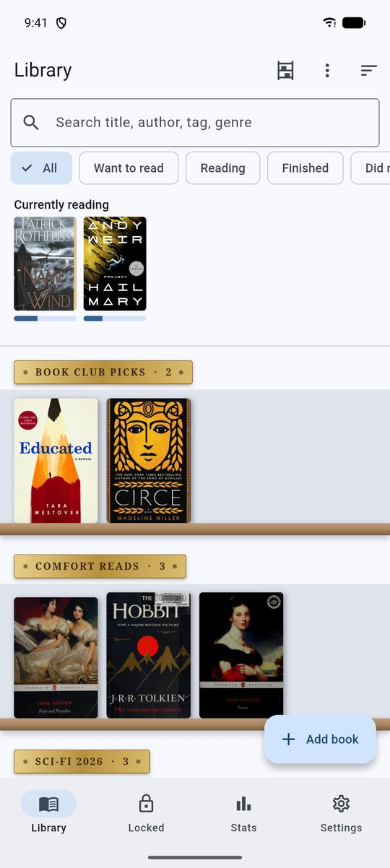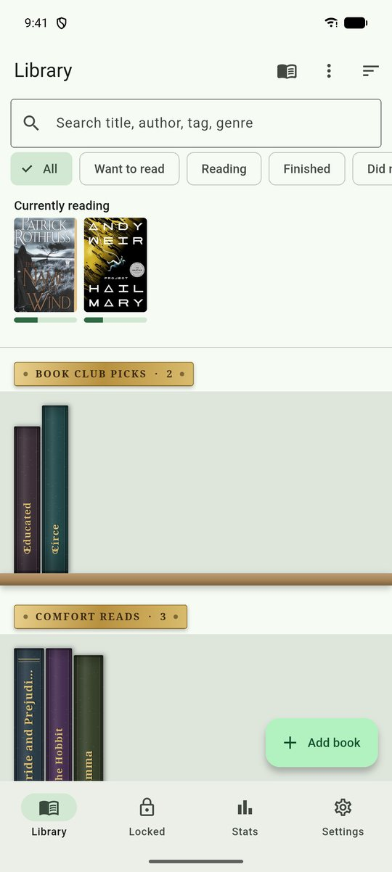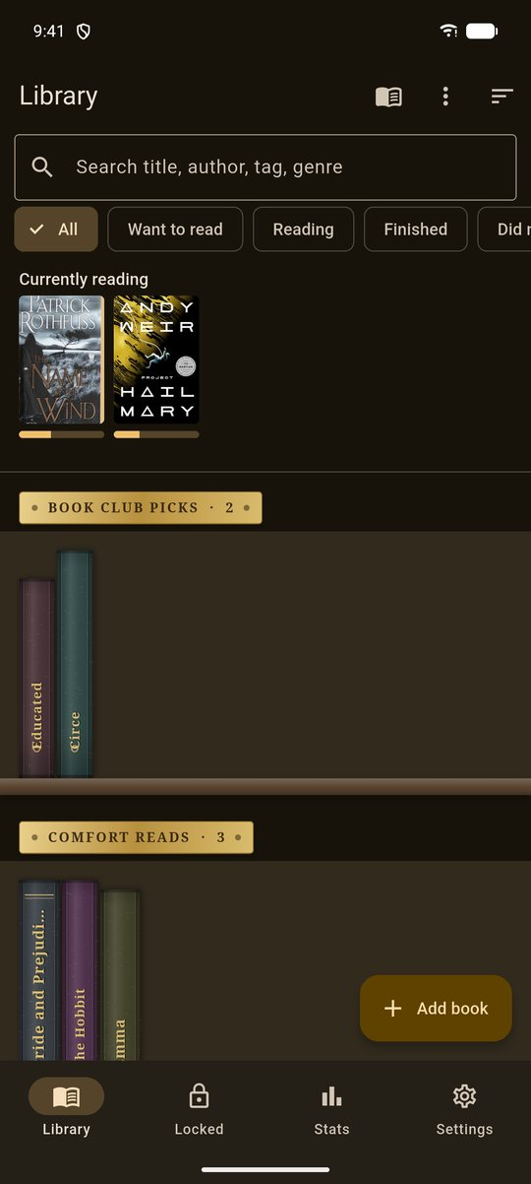
Bookshelf grouped by shelf · Sage, with Spines grouped · Lamplight

5b. Quotes, authors, covers and series

Quotes
On a book's page, Add quote saves a passage with its page number and an optional note about why it stuck. Tap a quote to edit it; its ⋮ menu can copy or share it (as the quote followed by author, title and page) or delete it (with Undo). The Library search box also searches your quotes, so you can find a book by a line from it.
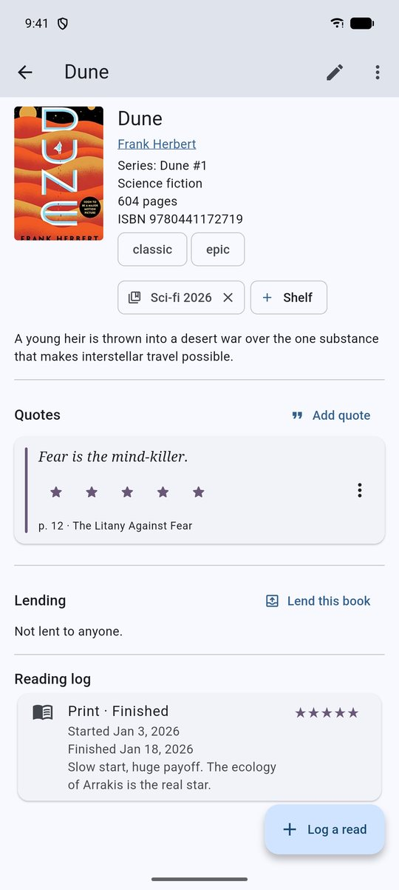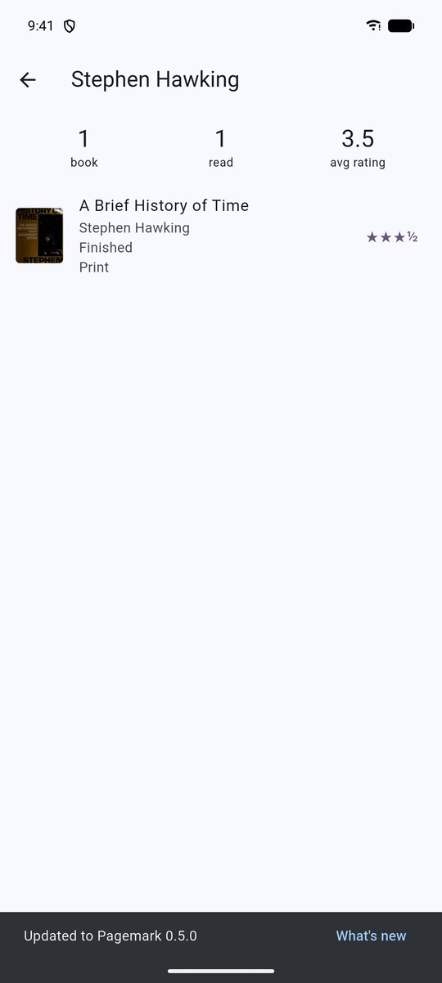
Quotes on a book page · An author page

Authors
Tap an author's name on a book to open their page: every book by them in this library, how many you've read and your average rating. (Locked books appear only inside the locked library.)

Covers on your phone
By default covers load from the internet. From a book's ⋮ menu you can Save cover on this phone (so it works offline and travels in backups), Choose cover from gallery, or Remove saved cover (the web cover returns). Settings → Your library → Cover pictures shows how many are saved and can save them all in one go, with a Stop button, and tidy unused files. Covers of locked books are saved too; they stay on the phone and are in backups, so protect backups with a password.

Series totals
In Edit, Books in the series records how long the series is. The Series screen then says things like "2 of 7 read · 5 not in your library".

Heat and content notes (optional)
Settings → Your library → Heat level and content notes adds two private fields to each read: a 0–5 flame rating and a content-notes line. They show on the book page, add a Heat chart to Stats, and are *left out* of CSV/JSON exports unless this switch is on. It is off by default.

6b. Selecting many books, and swiping
Long-press any book (in any Library style) to start selecting; tap other books to add or remove them. The bar at the top shows how many are selected and offers:
Button | What it does
Select all | every book currently shown (respects your search and filters)
Double tick | mark finished today: the active read becomes Finished with today's date; books with no read get one
Shelf | add them all to a shelf (or make a new one)
Padlock | move them to the locked library (or, inside the vault, back to the main library)
Bin | move them to Trash

Every one of these shows an Undo message afterwards (Undo for *add to shelf* takes off only the books it added). Press Back or the × to leave selection mode.
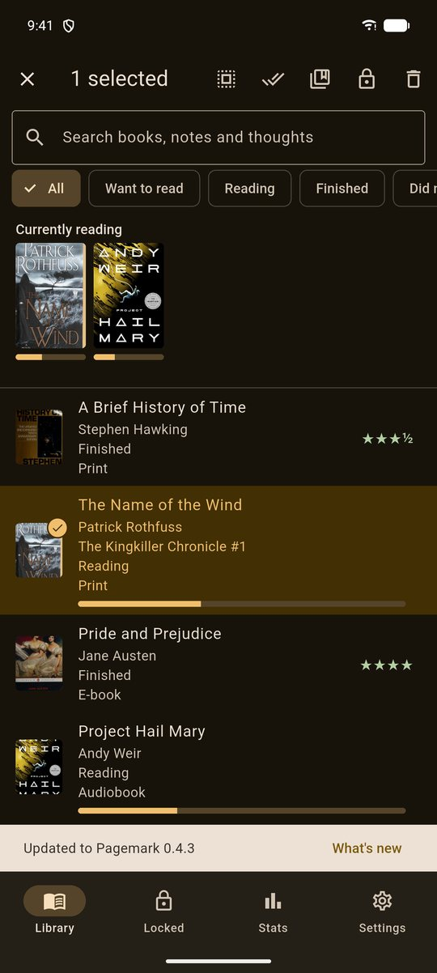
A book selected, with the bulk-action bar
In the Classic and Compact styles you can also swipe a row right to mark it finished today, or swipe left to move it to Trash (with Undo).

7. Stats
The Stats tab counts your main library only — locked books never appear in it.
- Reading goal — set how many books you want to finish this year. An animated ring shows progress, and Pagemark estimates how many you'll finish by 31 December at your current pace.
- Finished per month and Your ratings (how your ratings are spread, and your average).
- Year in books — a picture card for the year so far: books finished, pages, hours, favourite genre, most-read author, average rating and your top-rated book. Share picture sends it as an image; Report (PDF) makes a printable list of every book you finished this year with dates, pages and stars (letters outside Western European ones print as ?). Only your main library is used, never the Locked one.
- Days you read — a calendar, month by month (use the arrows). A filled circle is a day you read: a day with a timer session, or a day you started or finished a book. When you have read two or more days in a row a friendly line says so; there is never a "you missed a day" message.
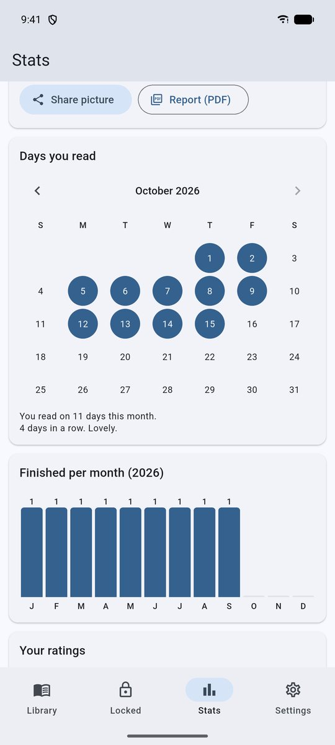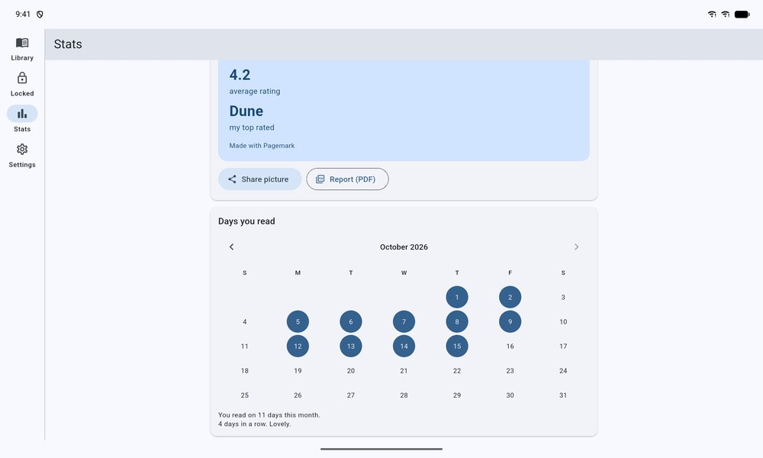
Days you read, and the Year in books card · Stats on a tablet
- Totals — books tracked, finished, pages, logged time, average days to finish, and finished books by format.
- Top genres and Top authors.
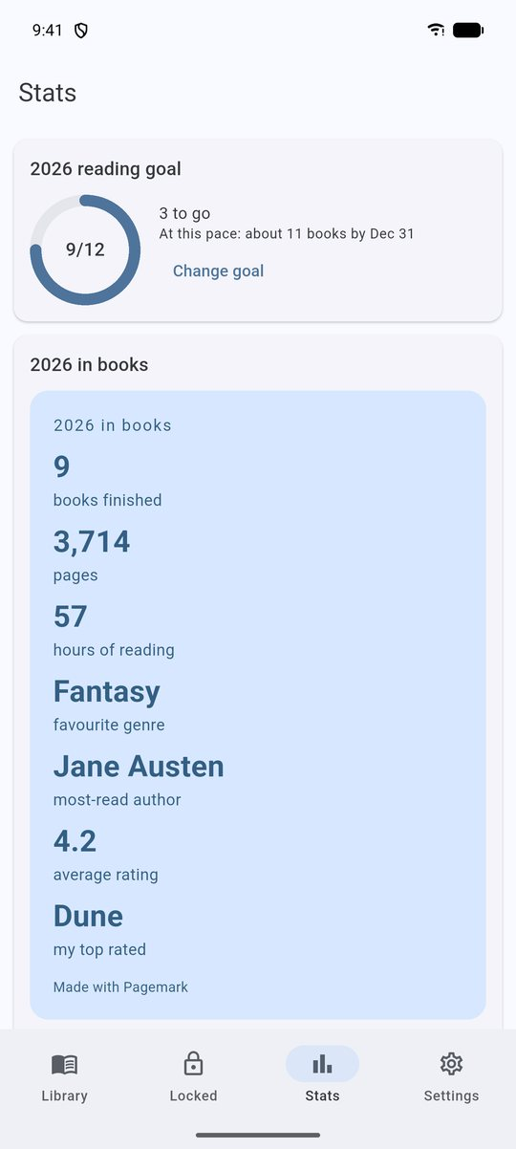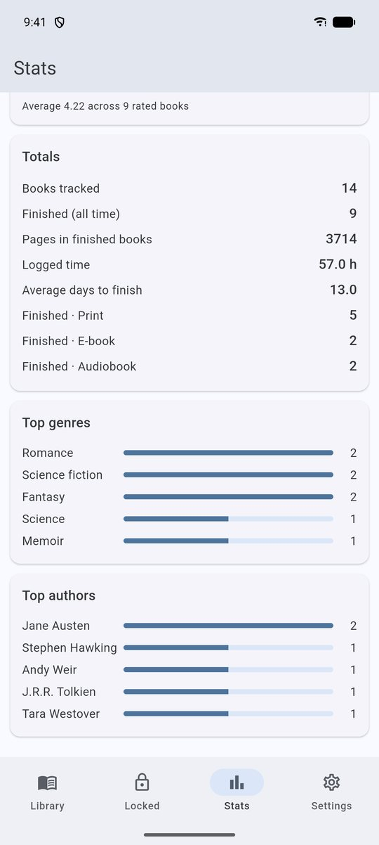
Goal and charts · Totals and rankings

8. The Locked library
A second library for books you want kept private. Nothing in it shows in the main library, Stats, Trash, exports or searches.

Setting up
Open the Locked tab the first time and choose:
- Set a PIN — 4 to 12 digits, entered twice. Pagemark then shows a recovery code once. Write it down. It is the only way back in if you forget your PIN.
- Use fingerprint / device lock only — uses your phone's screen lock. Needs a screen lock to be set up on the phone.

Using it
Enter the PIN (or use the fingerprint button). Add books while the Locked tab is open, or move any book across with its ⋮ menu.
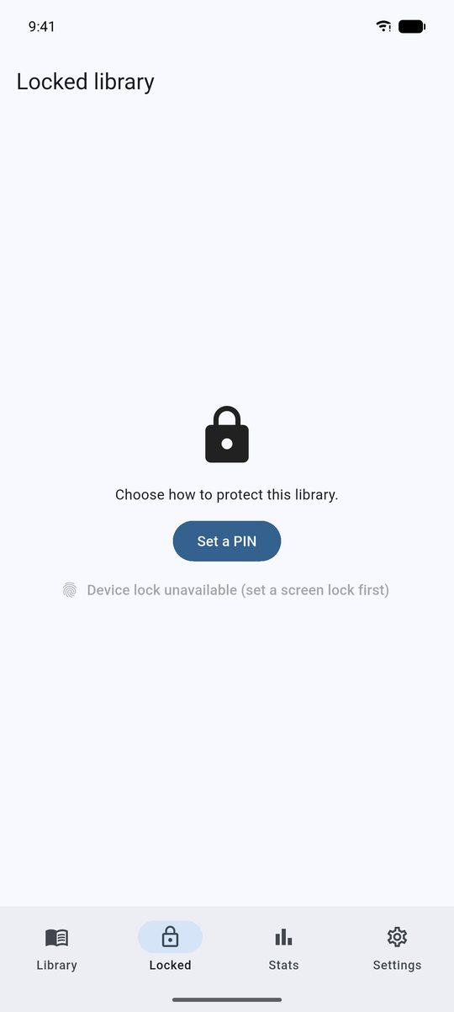
First visit to the Locked tab

Lock the whole app, and how long it waits
Settings → Privacy and lock has two more options:
- Lock after leaving the app — *Immediately* (default), *After 1 / 5 / 15 minutes*. This is how long Pagemark may sit in the background before it asks again. It applies to the locked library and to the whole-app lock below.
- Lock the whole app — Pagemark asks for your PIN or fingerprint every time it opens, and when you return after the delay. It uses the same PIN as the locked library (turning it on walks you through setting one). While it is showing, screenshots and the app-switcher thumbnail are blocked, nothing can be opened over it, and Back leaves the app.
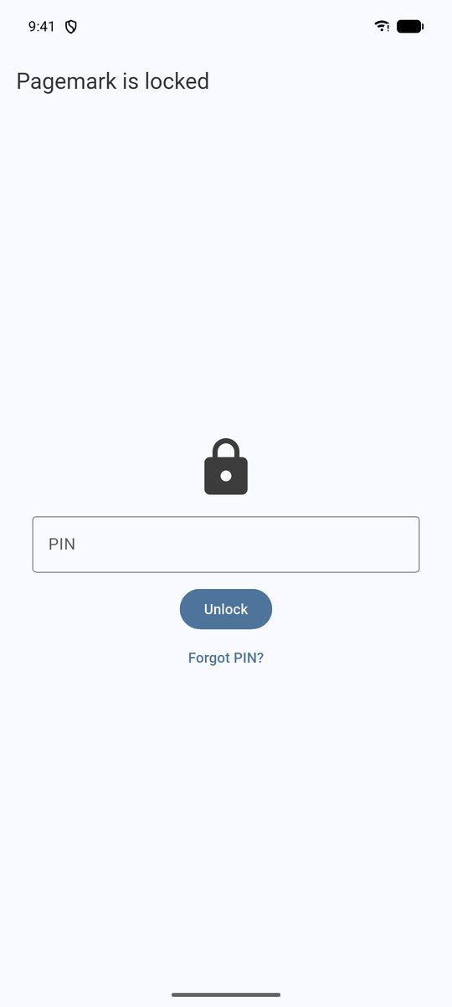
The whole-app lock

Protection you can rely on
- Wrong PINs are limited. After 5 misses the PIN is locked out for 30 seconds, doubling after every further 5 misses (up to 1 hour).
- It re-locks itself when you leave the tab or put Pagemark in the background. Open locked screens close, locked covers are wiped from the image cache, and temporary export files, including the copies the share sheet and file picker keep, are deleted the next time Pagemark opens or the vault closes.
- No screenshots. While the vault is open the screen can't be captured and the app-switcher thumbnail is blank.
- Changing the lock needs the lock. Changing or removing the PIN asks for the current PIN (or your fingerprint first).

Forgot your PIN?
On the lock screen tap Forgot PIN?, enter the recovery code and a new PIN. You'll receive a new recovery code; the old one stops working.

Settings → Privacy and lock
Lock now, Set or change PIN, and Remove lock (which asks for the current PIN first; locked books stay in the locked library, and the whole-app lock switches off because it needs a PIN). If Android ever clears Pagemark's saved lock, the library stays closed until you confirm with your phone's screen lock and set a new PIN.

8b. Reminders, widget, sharing and shortcuts
Notifications. Settings → Notifications holds all of Pagemark's reminders; Android asks once for permission to send notifications, and a red box with Turn on appears if they are switched off for Pagemark. Daily reading reminder: pick a time; Pagemark schedules the next three weeks and tops them up every time you open it. The text never names a book. Remind me to back up and Lend this book reminders work the same way. Reminders are set with Android's alarm service and set again every time you open Pagemark. Android, and Samsung's battery settings in particular, may deliver a reminder a few minutes late or hold it while the phone is in deep sleep; if one never arrives, check Settings → Apps → Pagemark → Notifications and Battery (set it to *Unrestricted* if your phone offers that).
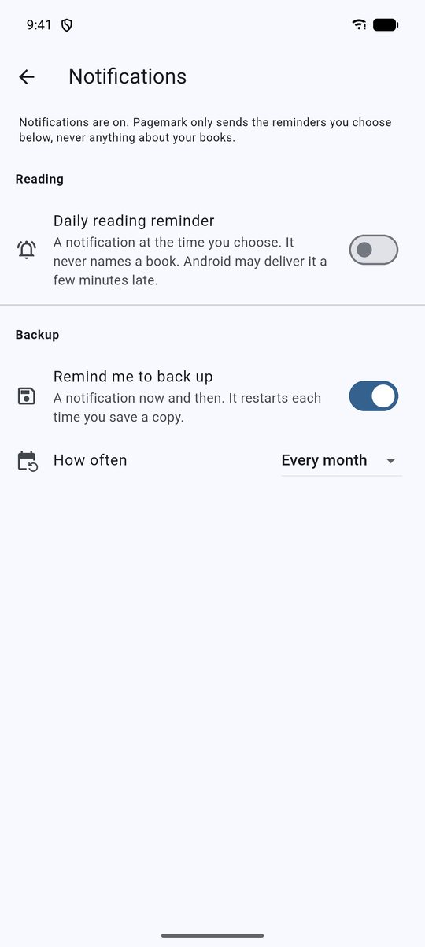
Notifications settings
Home-screen widget. Long-press the home screen, choose *Widgets*, then *Pagemark*. It shows up to three books you are reading and your yearly goal, and opens Pagemark when tapped. It is fed from the main library only, so the locked library never appears. Turn off Show book titles on the home-screen widget to show counts instead; with the whole-app lock on it always shows counts, because a widget can be seen without unlocking.
Share to Pagemark. In any app, Share → Pagemark. An ISBN is looked up directly; a Goodreads or Open Library link is searched by the title in its address; other text is searched as typed. You land on *Add a book* with the results, and nothing is saved until you choose one.
Shortcuts. Long-press the Pagemark icon: Add book and Reading now.

8c. First start, samples and defaults
The first time you open Pagemark you see three welcome screens (Skip any time). At the end you can add your first book, Try it with 5 sample books, restore a saved library, or Just look around. Sample books are removed with the Remove button on the card at the top of the Library, or Settings → Your library → Remove the sample books. With a few books and no backup, the Library offers a Set up card for backups. When a search finds nothing, Pagemark suggests shorter searches. Settings → Your library also has How dates look and New reads start as.

8d. Our promise to you, and accessibility
Settings → Our promise to you says in plain words what Pagemark will never do, and tests in the project fail if the app ever stops being true to it: no data collection, no account, no ads or in-app purchases, no tracking or analytics, no AI inside the app, and the internet used only where listed on that page (book searches, the update check on the GitHub version, and the barcode reader's note). Under The small print it names the places the internet is used and explains that the barcode reader uses Google's on-device ML Kit, which finds the barcode on your phone and never sends the picture anywhere.
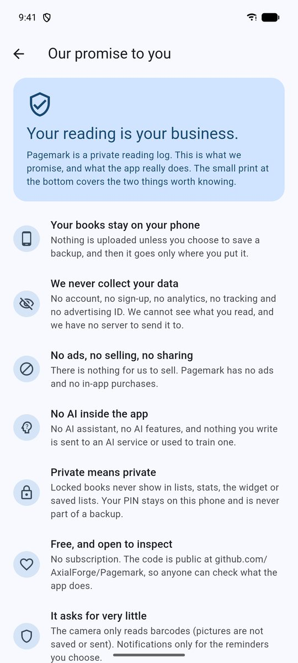
Our promise to you
Large text and display size. Pagemark was tested with Android's font size and display size at their largest, and with bold text; nothing is cut off and the buttons stay tappable. Welcome screens scroll when the text is large.
TalkBack. Star ratings are one control that says "3 of 5 stars" and can be swiped up or down in half stars. Cover pictures and icon buttons have names. Calendar days are spoken with their date and whether you read. Reordering the Read next list offers *Move up / Move down*. (TalkBack has had less testing than the rest: tell us what you find.)

9. Themes
Settings → Appearance offers six looks, each named for its mood:
Theme | Mode | Feel
Harbor | Light | calm slate blue (the default)
Midnight Ink | Dark | deep blue-black
Rosewater | Light | soft rose
Plum Velvet | Dark | rich plum
Sage | Light | gentle library green
Lamplight | Dark | warm reading-lamp amber

Your choice is remembered. The Library styles pick up the theme too: the bookcase wall, the spine colours and the rating stars all follow it.
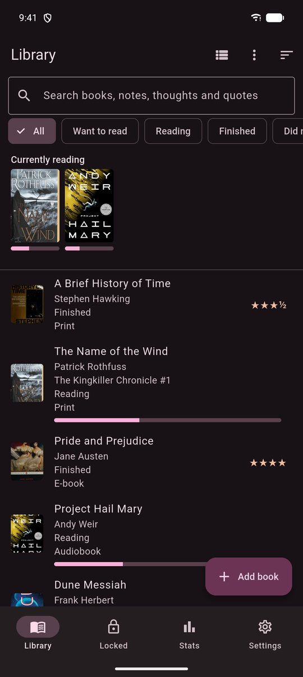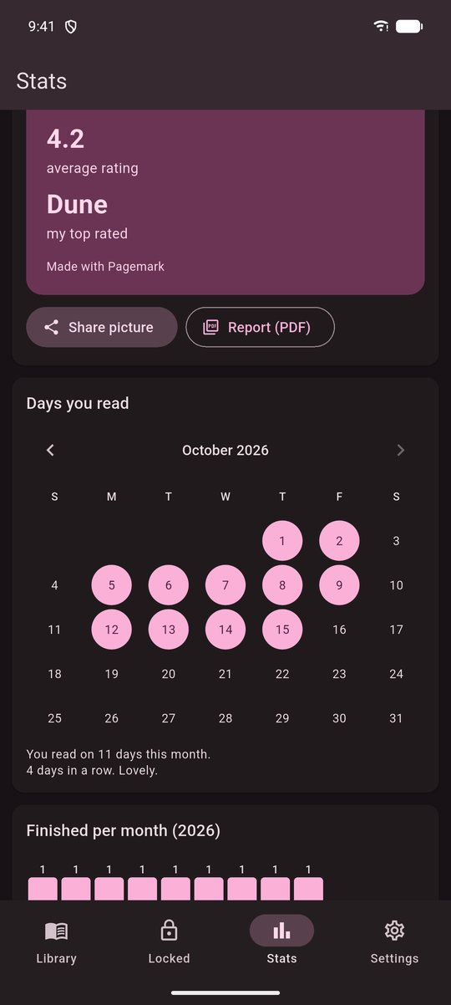
Plum Velvet · Stats in the dark theme

10. Exporting your data
Settings → Import and export (main library only — locked books are never included):
- CSV — opens in Excel, Numbers or Sheets (accents display correctly; cells that look like formulas are made safe).
- JSON — structured, with a format version.
Settings → Backup and restore (includes locked books):
- Save a copy as a file — a complete copy you can restore on another device. You'll be asked for a password; leave it empty only if you understand the file will be readable by anyone who gets it.
- Restore from a file — see §12.

10b. Importing your reading history
Settings → Import and export → Bring in books from another app brings books in from another app or from a Pagemark export:
- Goodreads — on the Goodreads website: My Books → Import and export → *Export Library*.
- StoryGraph — Manage Account → Manage Your Data → *Export*.
- Pagemark — a CSV or JSON file made by Settings → Import and export (also handy for moving to a new phone's main library).
Choose the file and Pagemark shows what it found: how many books and reads, how many are new and how many you already have, which shelves it would create, and any rows it had to skip (for example a row with no title). For books you already own you choose to skip them, add the file's reads to your existing entry, or import them as separate copies. Press Import: a safety copy of your library is saved first, and everything is added in one step — if anything goes wrong, nothing changes. Afterwards Undo import moves the new books to Trash.
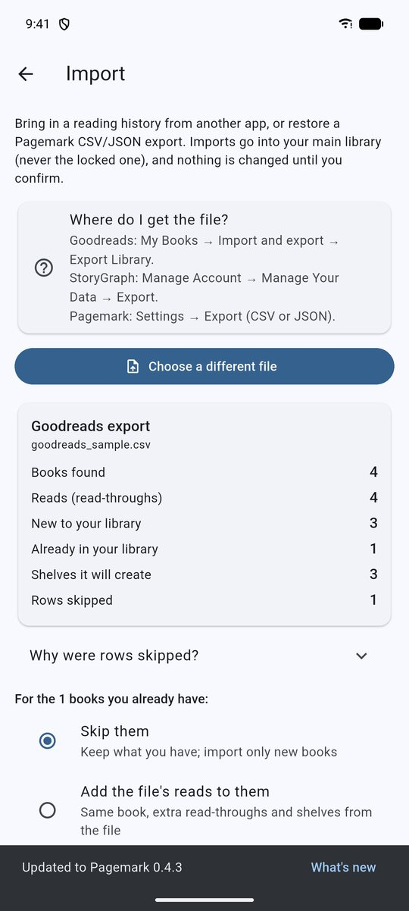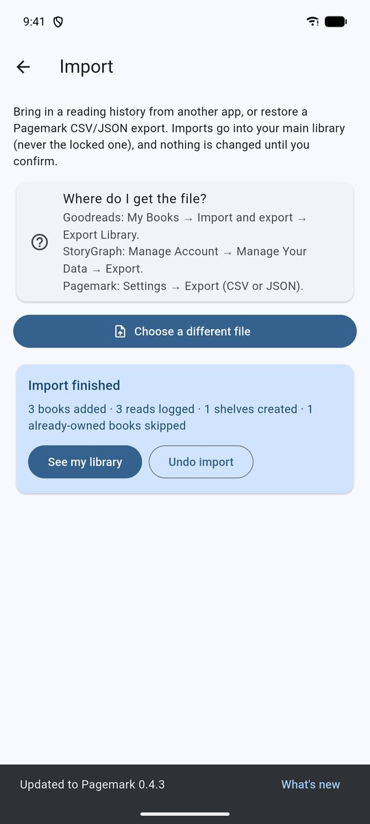
What the file contains · After importing
What gets mapped: statuses (read, currently reading, to-read, did-not-finish), ratings (rounded to the nearest half star), the date you finished, your review text, print / e-book / audiobook, ISBNs (so covers appear), and your Goodreads shelves become Pagemark shelves. Imports never touch the locked library, and "already have" only compares against your main library.

11. Backups
Settings → Backup and restore. The top of the page shows when you last saved a copy.
- Save a copy as a file: one file with your whole library, locked books included. Choose a password (recommended) and remember it: without it nobody can open the file, not even Pagemark. Keep the file somewhere other than this phone (email, Google Drive, a computer).
- Save my list as a spreadsheet: a list for Excel or Google Sheets. Locked books are not included.
- Save backups to a folder automatically: tap Choose a folder once and pick a folder with Android's own file picker (on the phone, a USB drive, or inside Google Drive, OneDrive or Dropbox). Pagemark then saves a fresh backup there when you open the app and one is due (every day, week, 2 weeks or month, your choice) and keeps the newest 5. You can protect them with a password. Back up now saves one straight away.
- Remind me to back up: a notification every week, two weeks or month (your choice), counted from the last time you saved a copy. Android 13 and newer asks once for permission to send notifications.

12. Restoring
From a file (Settings → Backup and restore → Restore from a file), or from the folder Pagemark saves backups to:
- Pick the backup. If it is encrypted you'll be asked for its password.
- Pagemark checks it is a healthy Pagemark database from this or an older version, and tells you how many books and reads it holds.
- It keeps a restore point of your current library (the newest 3 of each kind are retained inside the app), then replaces the library and asks you to close and reopen the app.
Going back: Settings → Backup and restore → Go back to an earlier copy lists the copies Pagemark kept before each restore and import. Tap one to restore it the same way.
If the backup holds locked books, Pagemark reminds you that your PIN is not part of backups — open the Locked tab and set a new PIN afterwards.
A damaged, foreign, or too-new file is rejected before anything changes.

13. Updates
Settings → Updates (or the dot on the Settings tab).
- Shows the version you have and whether a newer one exists, how many releases you're behind, the download size, and what changed in each.
- (Not in the Google Play version, where Play does the updating.) Download & install fetches the right file for your phone, checks its size and checksum, and opens Android's installer. The first time, Android asks you to allow installs from Pagemark. The update installs over the current app, so your library and settings are kept.
- Check automatically (on by default) does a quiet check at most once a day. The only thing sent is a request to GitHub for the release list. Switch it off any time.
- What's new shows every change in every release, offline. After an update, a What's new prompt links to it.
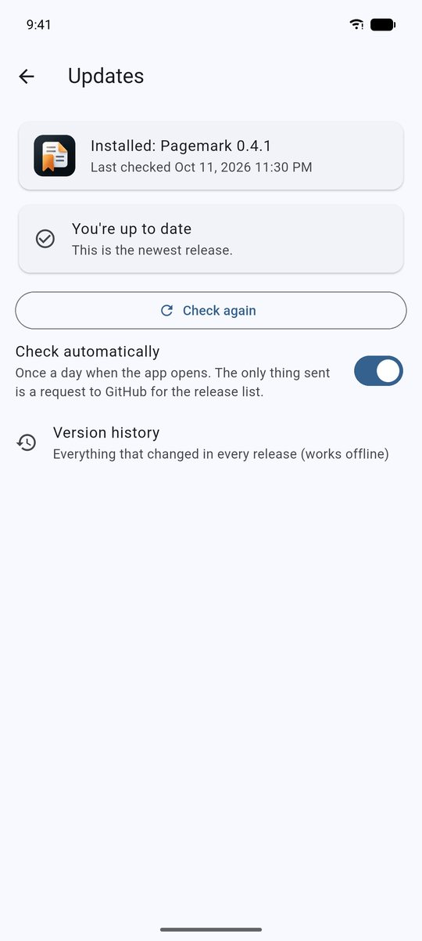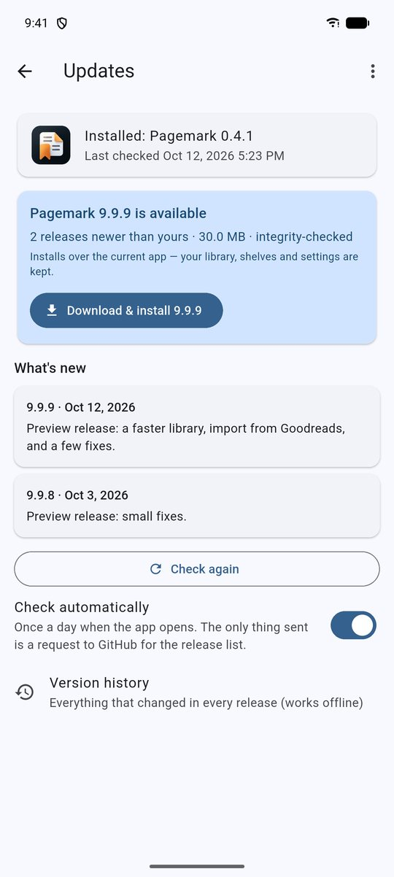
Updates · An update is available

14. Trash
Deleting a book moves it to Settings → Your library → Deleted books. Restore it, or delete it forever; anything left is removed automatically after 30 days. Books deleted from the locked library have their own Trash: unlock the vault, then choose ⋮ → Trash. They wait the same 30 days, and the main Trash never lists them.

15. Diagnostics
Settings → Help and about → Problem report shows a small rolling event log (errors, background backup runs, lookup problems). Database error details are removed before anything is written, so it does not keep your titles or thoughts. Copy it when asking for help; Clear it when done.

16. Your privacy, in plain terms
- Your library is stored only in a database file inside the app, and Android's own cloud backup is switched off for it.
- Pagemark sends book searches to Open Library and, unless you turn it off, Google Books, and update checks to GitHub (the GitHub version only). If you choose a backup folder inside a cloud app such as Google Drive, that app uploads the files under its own rules; Pagemark never signs in to anything. Backups are saved only where you choose.
- Nothing is sent to the developer. There are no accounts, ads or analytics.
- Cover images are downloaded from Open Library or Google Books and cached on the phone; locked covers use a separate cache that is cleared whenever the vault closes.

17. Troubleshooting
Problem | What to do
Search says it couldn't reach Open Library | Check your connection and try again; Pagemark retries busy servers automatically. You can always Add by hand.
A scanned barcode does nothing | Only ISBN book barcodes (starting 978 or 979) are accepted. Try the torch, or type the ISBN.
Covers are blank offline | Covers are downloaded on demand and cached; they appear once they've loaded online.
Forgot the PIN and lost the recovery code | The locked library can't be opened — that is the point of the lock. Removing the lock also needs the PIN, and the PIN is not part of backups, so a restore won't help. Keep the recovery code safe.
Backup shows FAILED | Open the backup page for the message; also see Settings → Help and about → Problem report.
A reminder never appears | Settings → Notifications must say notifications are on. On Samsung and other phones, open Settings → Apps → Pagemark → Battery and choose *Unrestricted*, and make sure "Sleeping apps" does not list Pagemark. Open Pagemark once after updating so reminders are scheduled again.
A book search says it is busy or offline | The message names the reason. Wait a moment and try again; you can always Add by hand.
Every other book says a timer is running | Tap Stop it and choose to save or throw away the time.
Update says no releases found | The project's releases page must be public. Check your connection.
"App not installed" during an update | Usually a different signing key (e.g. a debug build over a release build). Back up, uninstall, and install the release APK.

18. Glossary
- Read — one read-through of a book (format, dates, rating, thoughts).
- Shelf — a free-form group of books; a book can be on many.
- Locked library — the PIN-protected second library.
- Recovery code — one-time code that resets a forgotten PIN.
- ISBN — the number on a book's barcode that identifies an edition.
- Session — one stretch of reading recorded by the reading timer.
- Loan — a note that a book is lent to someone, with an optional reminder.
- Revision — the version of a document (for example *Rev 1.2*); newer revisions never replace older files.

